# Magnetic Design

Since the controller to be used will receive the power supply over transformer winding, a transformer with 3 windings will be designed. The transformer schematic can be seen in figure X.

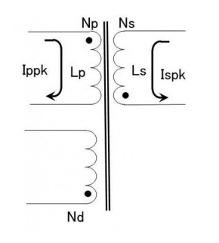

Figure X. Transformer schematic

Considering the size of the transformer to be designed, duty cycle should be less than 0.5. As the duty cycle increases the size of the transformer should increase as the energy to be stored increases. The flyback reflected output voltage (VOR) is equal to the secondary output voltage plus the secondary diode on voltage (VO) multiplied by the transformer winding ratio (Np/Ns). Flyback reflected output voltage indicates the winding ratio and the duty cycle ratio (D). Diode forward voltage is assumed to be 1 V in calculations. Moreover, In the iterative calculations, it was decided that the winding ratio should be 26/6.

|  |  |
| --- | --- |
| $$VO=Vout+V_{F}, VO=12+1=13 V$$ |  |
| $$VOR=VO*\frac{Np}{Ns}, VOR=13*\frac{26}{6}=56.333 V$$ |  |
| $$Dmax=\frac{ VOR}{(Vin_min+VOR)}, Dmax=0.204$$ |  |

The minimum input voltage value to be used in the project is 220V, so the maximum duty cycle value has been calculated accordingly. Also, the sum of the input voltage value and the reflected output voltage value indicates the maximum breakdown voltage that will fall on the switch.

Then, the secondary winding inductance (Ls) value and the secondary-side peak current (Ispk) value are calculated. Since the controller tries to make the converter to work in boundary mode, the calculations are made according to discontinuous mode (The worst case). The most critical point in this calculation is the point where the output current is maximum, so the calculations are made accordingly.

|  |  |
| --- | --- |
| $$Iout_{max}=\frac{Pout}{Vout}, Iout_{max}=8.333 A$$ |  |
| $$Ls=\frac{\left(Vout+V_{F}\right)*{\left(1-D_{max}\right)}^{2}}{2*Iout_{max}*fsw_{max}}, Ls≤4.9μH, Ls=4.34μH$$ |  |
| $$Ispk=\frac{2*Iout_{max}}{1-D_{max}}=20.1 A$$ |  |

In simulations made with the controller, it was determined that the maximum frequency used by the controller was 100kHz, so the calculations were made by taking the maximum frequency of 100kHz. For the converter to work in boundary mode, the inductance value must be close to or smaller than the calculated value.

|  |  |
| --- | --- |
| $$Lp=Ls*{\left(\frac{Np}{Ns}\right)}^{2}=81.5 μH$$ |  |
| $$Ippk=\frac{Ispk}{Np/Ns}=4.83 A$$ |  |

Primary winding inductance (Lp) and the primary peak current (Ippk) were calculated using winding ratio from the calculations made for the secondary side.

After these calculations, the size of the transformer and the magnetic material to be used were decided. PC47EI25 was decided to be used as a result of the iterative calculations made by also looking at the fill factor. The size of the EI25 core is sufficient for the project and the magnetic properties of the PC47 ferrite core used are also suitable for the project purpose.

**Table.X** Magnetic Properties of the PC47EI25

|  |  |  |  |
| --- | --- | --- | --- |
|  | Effective cross-sectional area Ae (mm2) | Maximum Magnetic Flux density (T) | AL-value with air gap  (nH/N^2) |
| PC47EI25 | 41 | 0.42 | 125 |

By using an air-gapped ferrite core, the transformer cost was kept low, and it provided an advantage in size. Using these properties of the transformer, primary winding turns (Np) can be calculated. The primary winding turns must be adjusted so that the core cannot be in saturation during operation (equation XXX). Lp value can be designed with AL-Value and Np (Equation YYY). Also, maksimum MMF value in the core can be calculated with equation ZZZ. After calculating the primary winding turns, the secondary winding number can be calculated using winding ratio (Equation WWW). In addition, since the input voltage is equal to the output voltage in the controller, the number of winding turns must be equal (Equation QQQ).

|  |  |
| --- | --- |
| $$Np=\frac{Vin*D*Ts}{Ae*Bsat}=Lp*\frac{Ippk}{Ae*Bsat}=22.8, Np≥22.8$$ | (XXX) |
| $$Np=\sqrt{\frac{Lp}{AL}}=25.53, Np=25$$ | (YYY) |
| $$MMF=\frac{Np}{Ns}*Ippk=120 A.t$$ | (ZZZ) |
| $$Ns=\frac{\frac{Np}{Np}}{Ns}=6$$ | (WWW) |
| $$Nd=6$$ | (QQQ) |

Finally, physical dimensions of the transformer core and cables to be used are needed to make fill factor calculations. Core dimension values are taken from datasheet. It can be seen in Figure X, table X and table Y. While choosing the cable, attention has been paid to ensure that the current value that the cable can carry is higher than the maximum current values.

Table X. Core Dimensions

|  |  |  |  |  |  |
| --- | --- | --- | --- | --- | --- |
| Core | A (mm) | C(mm) | D (mm) | E(mm) | F (mm) |
| EI25 | 25.3 | 5.75 | 6.5 | 19 | 12.35 |

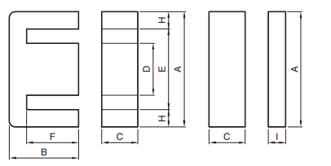

Figure X. Core Dimensions

Table Y. Cable Properties

|  |  |  |  |  |  |
| --- | --- | --- | --- | --- | --- |
| Wire | Area (mm2) | Diameter(mm) | Ampacity (75°C) | Resistivity (p) (10^-8 Ω.m) | Absolute magnetic permeability(u)  (10^-7 H/m) |
| AWG10 | 5.26 | 2.588 | 35 | 1.678 | 12.55 |
| AWG20 | 0.518 | 0.812 | 11 | 1.678 | 12.55 |
| AWG30 | 0.509 | 0.255 | 0.86 | 1.678 | 12.55 |

Using these dimensions, the fill factor is calculated as in equation X, Y and Z.

|  |  |
| --- | --- |
| $$Window_{A}=\frac{A-D}{2}*F=116.1 {mm}^{2}$$ | (X) |
| $$Cable_{A}=AWG20*Np+AWG10*Ns +AWG30*Nd=48 {mm}^{2}$$ | (Y) |
| $$Fill_{Factor}=\frac{Cable_{A}}{Window_{A}}=0.41$$ | (Z) |

Furthermore, the distribution of current in a conductor is almost uniform when the system is DC. However, current in transformer behave as an AC current even though converter is a DC/DC converter. Current flows in a transformer conductor is not uniform, therefore, skin effect should be taken into consideration while choosing cable. Since skin depth dictates effective cross section area, it is significant while calculating AC resistance of the cables. The resistance values are calculated according to the following equations and as it is seen that the cable used AWG20 reaches the highest AC resistance value, the values of the AWG20 cable are calculated as an example. While making these calculations, the values in table x and table y were used.

|  |  |
| --- | --- |
| $$length=\left(C+\frac{D+E}{2}\right)*2, AWG{20}_{length}=length*Np=0.962 m$$ |  |
| $$Skin_{depth}=\sqrt{\left(\frac{p}{π*f*u}\right)}=207μm$$ |  |
| $$Effective_{Area}=Skin_{depth}*pi*Diameter, A_{eff_{AWG20}}=Skin_{depth}*π*AWG{20}_{d}=0.528mm2$$ |  |
| $$R_{AC}=p*\frac{length}{Effective_{Area}}, R_{AC_{20}}=p*\frac{AWG{20}_{length}}{A_{eff_{AWG20}}}=30 mΩ$$ |  |

The resistance values of AWG 10, AWG 20 and AWG 30 cables are 2, 30 and 22 $mΩ$, respectively, so they can be neglected.

---------------------New Information--------------- 03.06.2021

One of the important points of magnetic core selection is that the core must provide sufficient inductance values despite the decreasing AL value with DC-Bias. In Equation ZZZ (mmf calculation), the maximum MMF value is calculated with the maximum current value on the core, and when the datasheet of the core material is examined, it was observed that the core did not deviate from the axis in the graph at calculated MMF value as seen in FIGURE X (below). Also, the minimum number of turns required to avoid saturation is also calculated in equation XXX (ZZZ over two).

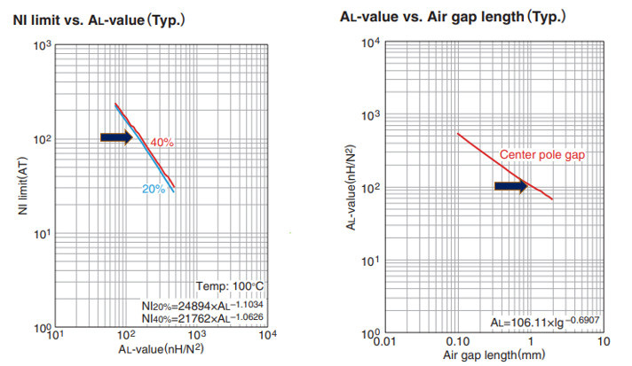

Figure X. NI limit and Air gap vs AL value Graphs

Since the transformer transfers the stored energy in the Flyback Converter design, a certain amount of air gap should be left in the core design. The 1 mm air gap will cause the AL value used for the design (Figure X above).

|  |  |
| --- | --- |
| $$Vp_{rms}*Ip_{rms}=\frac{Np*Ae*Bsat}{D*Ts}*Ip_{rms}=P_{o}=197.5 W$$ | (Eren) |
| $$Vp_{rms}*Ip_{rms}=100 W=\frac{Np*Ae*B_{operating}}{D*Ts}*Ip_{rms}, B_{operating} =0.2 T$$ | (Enes) |

As stated before, the core used in design is saturated at 0.42 T. When Faraday's law is used, the transformer can provide 197.5 W power with saturation flux density value (equation EREN). Again, using Faraday's law, the average operating flux density value can be calculated (equation ENES). It is note that there will be ripple in the flux density value during the operation without saturation.